January
2020
January is the month of the Holy Name of  Jesus | 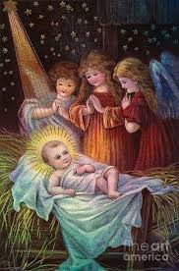
Sunday | Monday | Tuesday | Wednesday | Thursday | Friday | Saturday
 |  |  | 1 | 2 | 3 | 4
Religious Ed |  |  | 10 am Mass |  | NO Mass
5 | 6 | 7 | 8 | 92 | 10 | 11
Religious Ed |  |  | 9 am Mass  10 am - Legion of Mary |  | 9 am Mass - Church cleaning
12 | 13 | 14 | 15 | 16 | 17 | 18
Religious Ed |  |  | 9 am Mass  10 am - Legion of Mary | Parish Council  4 pm | 9 am Mass
19 | 20 | 21 | 22 | 23 | 24 | 25
NO Religious Ed  Martin Luther King |  |  | 9 am Mass  10 am - Legion of Mary |  | 9 am Mass
26 | 27 | 28 | 29 | 30 | 31
Religious Ed |  |  | 9 am Mass  10 am - Legion of Mary |  | 9 am Mass

