September
2020
Lady of Sorrows | 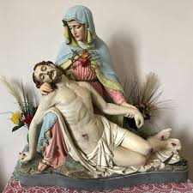
Sunday | Monday | Tuesday | Wednesday | Thursday | Friday | Saturday
 |  | 1 | 2 | 3 | 4 | 5
 |  |  |  |  | 9 am Mass  By reservation  First Friday  First Friday | 9 am Mass  NO 4 pm Mass
6 | 7 | 8 | 9 | 10 | 11 | 12
10 am Mass  By reservation |  |  | 9 am Mass  By reservation  Legion of Mary  10 AM in hall |  | 9 am Mass  By reservation | 4 pm Mass  By reservation
13 | 14 | 15 | 16 | `17 | 18 | 19
10 am Mass  By reservation |  |  | 9 am Mass  By reservation |  | 9 am Mass  By reservation | 4 pm Mass  By reservation
20 | 21 | 22 | 23 | 24 | 25 | 26
10 am Mass  By reservation |  |  | 9 am Mass  By reservation  Legion of Mary  10 AM in hall |  | 9 am Mass  By reservation | 4 pm Mass  By reservation
27 | 28 | 29 | 30
10 am Mass  By reservation |  |  | 9 am Mass  By reservation

